**Lab#4:**

**Objective: RMI CALLBACK.**

**Task#1:** Develop the RMI Call back application of Payroll and Payroll Message services for calculating the earnings.

**Interface:**

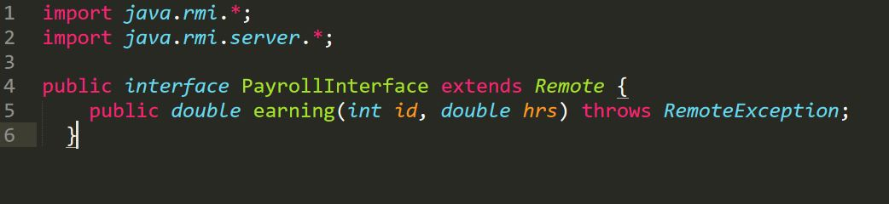

**MessageInterface:**

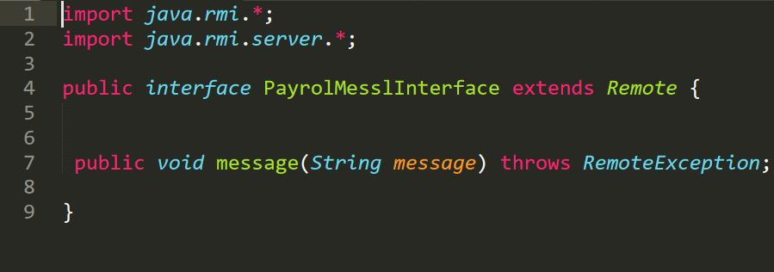

**Payroll:** 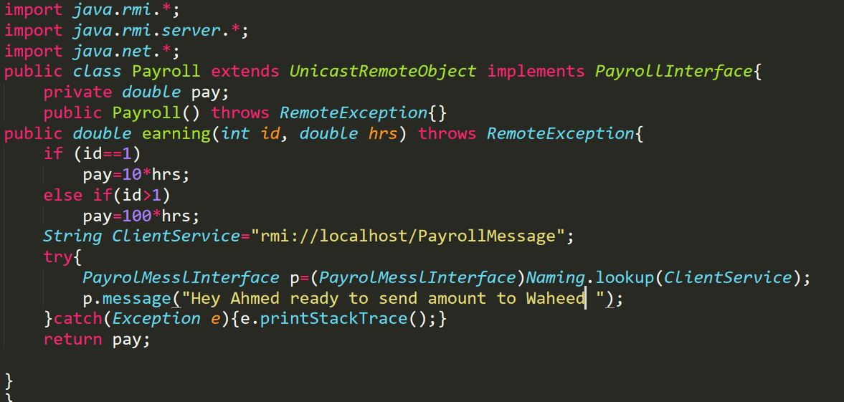

**PayrollServer:**

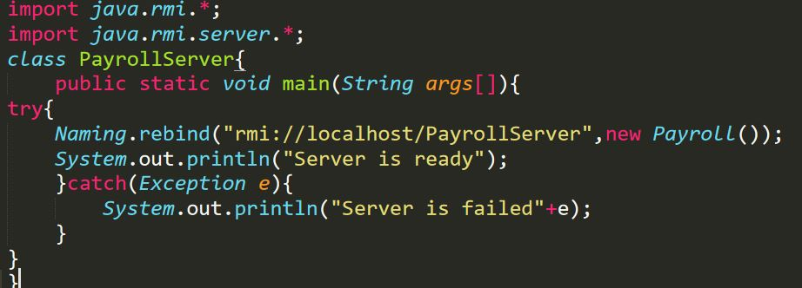

**PayrollMessage:**

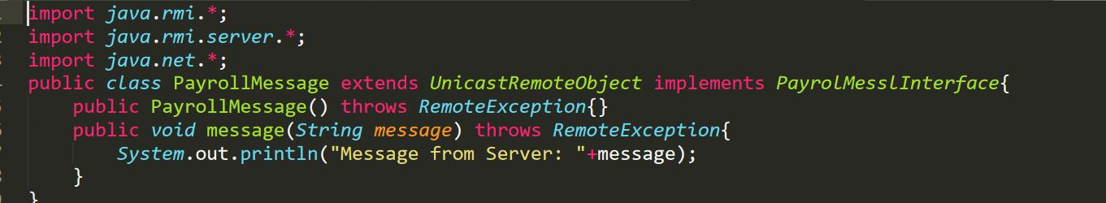

**PayrollMessageServer:**

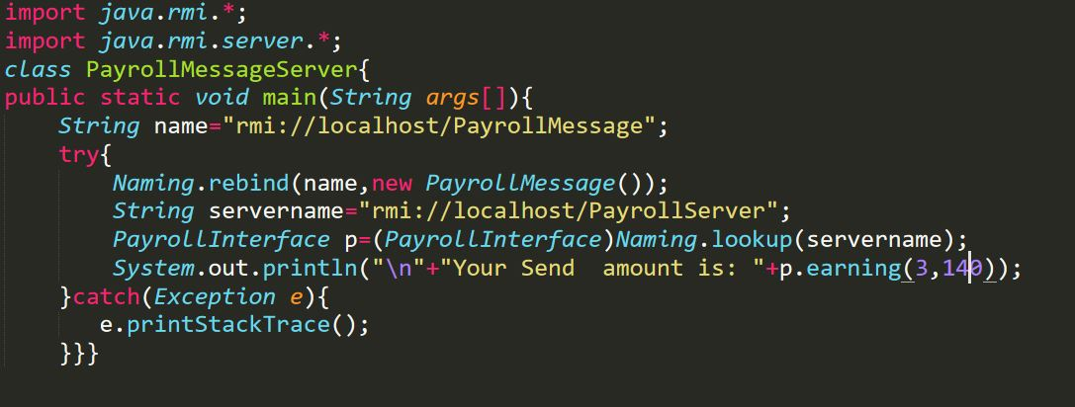

**Output:**

